Data Structures & Algorithms (CSC-214) Semester: Spring 2025
Handout: Recursion 1

- What is the output of the following code?

#include <iostream>
using namespace std;

int gcd(int x, int y)
{
if (x % y == 0)
return y; // What case is this?
else
return gcd(y, x % y); // What case is this?
}

int main()
{
cout << gcd(20, 8) << endl;
return 0;
}

- What is the output of the following program.

#include <iostream>
using namespace std;

int function(int num) {
if (num <= 0)
return 0;
else
return function(num − 1) + num;
}

int main() {
cout << function(10) << endl;
}

- What is the output of the following code?

#include <iostream>
using namespace std;

void function(int num) {
if (num > 0)
{
for (int x = 0; x < num; x++)
cout << '*';

cout << endl;
function(num − 1);
}
}

int main() {
function(10);
}

- What is the output of the following code?

void function(string, int, int);

int main()
{
string mystr = "Hello";
cout << mystr << endl;
function(mystr, 0, mystr.size());
return 0;
}

void function(string str, int pos, int size)
{
if (pos < size)
{
function(str, pos + 1, size);
cout << str[pos];
}
}

- Convert the following function to one that uses recursion. How would the driver program be written for the recursive function?
void sign(int n)
{
while (n > 0)
cout << "No Parking\n";
n−−;
}

- Answer the following questions about the following code.
int recFunc(int num)
{
if (num == 0)
return 0;
else if (num < 0)
return (-num);
else
return (num - recFunc(num - 5));
}

- Identify the base case and the recursive case.
- If recFunc(20) is a valid call, what is its value? If not, explain why.

- Consider the following recursive function:
void funcEx8(int u, char v)
{
if (u == 0)
cout << u << " ";
else
{
int x = static_cast<int>(v);
if (v < 'A')
v = static_cast<char>(x + 1);
else if (v > 'Z')
v = static_cast<char>(x - 1);
cout << v << " ";
funcEx8(u - 2, v);
}
}

Answer the following questions:
- Identify the base and recursive case.
- If funcEx8(6, '$'); is a valid call, what is the output? If not, explain why.

- Consider the following recursive function:
void recFun(int x)
{
if (x > 0)
{
cout << x % 10 << " ";
recFun(x / 10);
}
else if (x != 0)
cout << x << endl;
}

What is the output of the following statements?
- recFun(36);

- Consider the following recursive function:
void recFun(int u)
{
if (u == 0)
cout << "Zero! ";
else
{
cout << "Negative ";
recFun(u - 1);
}
}

What is the output, if any, of the following statements?
- recFun(8);

- Consider the following recursive function:
void recEx11(int x){
if (x > 0)
if (x % 2 == 0)
{
recEx11((x - 3) / 2);
cout << x << " ";
}
else
{
recEx11((x - 4) / 2);
cout << x << " ";
}
}
What is the output of the following statements?
- recEx11(28);
- recEx11(-30);

- Consider the following function:
int recEx12(int a, int b)
{
if (a < b)
return a + b;
else
return recEx12(a - b, b + 1);
}

What is the output of the following statements?
- cout << recEx12(128, 15) << endl;

- Consider the following function:
int rec(int x)
{
if (x <= 0)
return 0;
else if (x == 1)
return 2;
else
return (rec(x - 1) + rec(x - 2) + rec(x - 3));
}

What is the output of the following statements?
- cout << rec(4) << endl;

- Consider the following recursive function:
void recFun(int x, int y)
{
if (x > 0 && y > 0)
{
if (x >= y && y != 0)
{
cout << x % y << " ";
recFun(x - y, y);
}
else if (y > x && x != 0)
{
cout << y % x << " ";
recFun(y - x, x);
}
}
else
cout << x + y << endl;
}

What is the output of the following statements?
- recFun(75, 26);
- recFun(13, 86);

- Consider the following recursive function:
int test(int x, int y)
{
if (abs(x - y) <= 1)
return x + y;
else if (x > y)
return test(x - 1, y + 1);
else if (y > x)
return test(x + 1, y - 1);
}

What is the output of the following statements? (4, 6)
a. cout << test(8, 2) << endl;
b. cout << test(5, 16) << endl;
c. cout << test(-25, 2) << endl;
d. cout << test(8, -6) << endl;
e. cout << test(-20, -36) << endl

- What is the output?
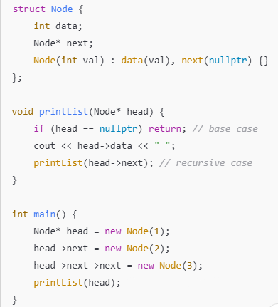

- What is the output? Assume the operation is performed on the linked list created in the above question.
